CoffeeNow Application

# Project Summary

The purpose of this project is to address common issues that average coffee drinkers face on a regular basis. These issues, made clear repeatedly through interviews and observations, are:

1. People must wait in line to place their order.
2. They must wait in line again for their order to be fulfilled.
3. They are frustrated at having to do this repeatedly, every time they want coffee, as there is no other option for ordering.
4. People are afraid of taking too long to place their order; they feel pressured to order quickly.
5. Finally, they are irritated at the high cost associated with drinking coffee and all the additional fees that are added to drinks with options.

After gaining these insights, our team brainstormed potential applications that could both streamline the process for regular coffee drinkers and provide them with the feeling that their time was not being wasted. We attempted to accomplish this with our application in the following ways:

1. By making the application convenient and easy to use.
2. By streamlining the process to reduce our users overall wait time.
3. By allowing to users to schedule their orders in advance.
4. By giving users the unhurried time to place their order, ensuring that they can pick and choose exactly what they want.
5. Making the total cost of the drink clearly visible to the user to help them gauge if they really want to pay for additional drink additives.

To achieve these goals our team came up with the **CoffeeNow Application**. After our research we realized that the majority of our users possessed cell phones and would often use them in line. We realized that this could potentially provide our users with the ultimate flexibility. It would allow our users to place orders for their drinks at various local coffee shops and pick them up when it was most convenient for them.   
  
We designed the application's interface and user experience using the insights gained above. Below is a screen shot of the start screen to our application that runs on the user’s phone:

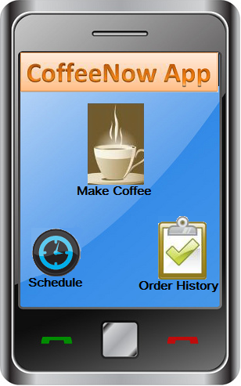

# Justifications

We chose this design because one of the main priorities for this application was to make it both convenient and easy to use. There are three main use cases for the application:

1. Make Coffee: Users can customize and make their own cup of coffee and then send the order (Eliminating the necessity of waiting in line, from #1 and #2 of our insights above).
2. Schedule: Allows users to schedule future orders (From #3 of our insights above).
3. Order History: Helps users keep track of custom drinks they have ordered in the past and their associated costs (From #5 of our insights above).

Making an icon for these three use cases allowed us to satisfy our user's needs but at the same time reduce clutter from unnecessary features (From insights #1 and #4 above).  
  
So, let’s look at the three main use cases:

## 1. Making Coffee

When users click on this icon it will take them through a Coffee Making Wizard. We used the wizard style because it has been employed many times before and with great success. It is a familiar style of interface, which both increases the ability to learn our application and reduces user confusion. Below is an example of what a user sees after clicking the "Make Coffee" icon:

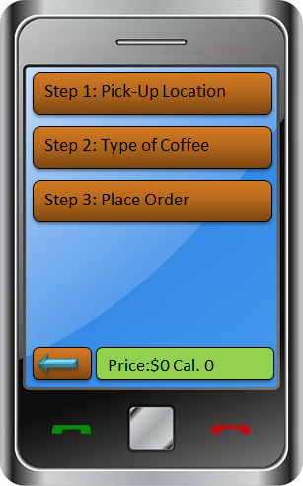

This is the beginning of the wizard; we broke up the coffee making process into manageable steps. The steps are also adaptive – they change based on the current order type. This helped reduce the overall complexity of our application and transformed it into more of an assembly line coffee making process. Furthermore, chunking up the process into individual steps should help improve both recognition and recall for the entire coffee making process. As users build their own cup of coffee they will complete steps. Each step that they complete will be indicated with a green check mark. This is shown below:

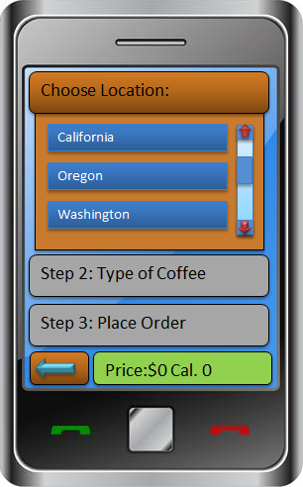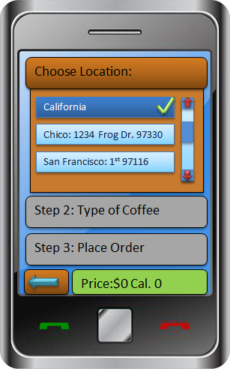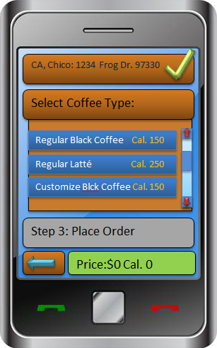

By placing big green check marks next to each step completed we provide annotating and cognitive tracing for our users, like crossing off items of a grocery list. It helps our users keep track of where they are in the interface and helps them quickly see where they need to go.

And, by having context aware submenus, users are able to focus on only what they need in the current moment, providing scent and positive feedback.

## 2. Schedule

When users click on the Schedule button on our Home Screen they are taken to the screen shown below.

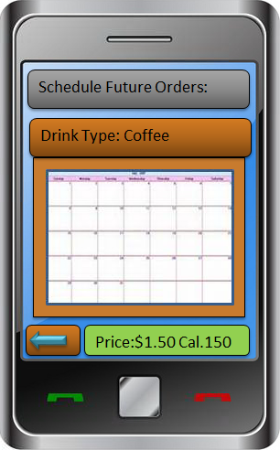

Here they are able to set up a recurring order. First they select their drink type, then they select the days from the calendar they would like to have that drink waiting for them. Finally, after they select the date/time they are rewarded with a cheerful confirmation message to let them know their order has been scheduled. They can look forward to their favorite beverage being ready on the days they scheduled without any more work on their part.

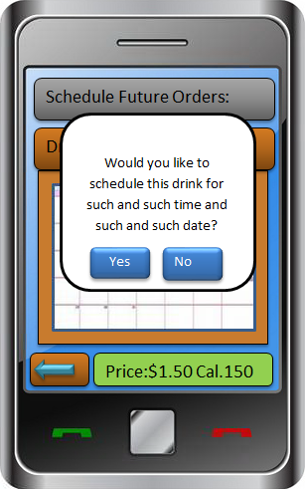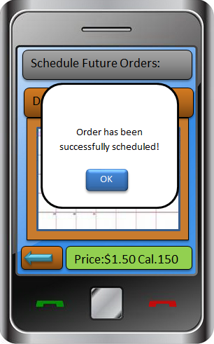

## 3. Order History

When users click on the Order History button on our Home Screen they are taken to the Order History screen shown below.

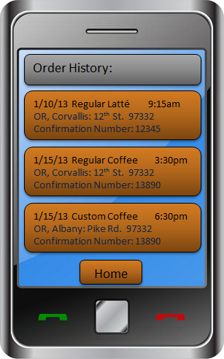

This screen provides our users the ability to see their most recent orders. This feature was implemented after reviewing feedback we received from our peers. One interviewee said, “A helpful addition might be a "recent orders" section that could potentially serve as a reminder to the user (UX #6) as well as saving them time (UX #7)." Many other users felt this way and after some deliberation we decided that this feature could potentially be valuable to our users.

With this feature, if users find that they want to reorder something, all they have to do is click on one of their past drinks. Doing so takes the users to a screen that allows them to quickly glance at the details of the order and order it again if they wish. They can also go back and make another choice. If the user chooses to order this custom drink again, they can click on the "Place Order" button.

Users can also make changes to their order, as they see fit.

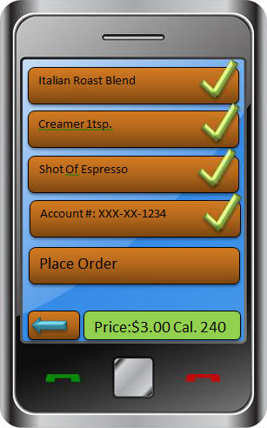

# Brief List of Changes since Interactive Design Gallery #1:

* Updated the general “look and feel” throughout for consistency of font, button style, coloring, etc.
  + Reason: since several people worked on different aspects of the app it had a bit of a disjointed feel.
* Strengthened the “list/checkmark feedback”
  + Reason: several respondents enjoyed the list and checkmark ordering process.
* Reduced the overall number of primary list items, made the list adaptive to the order
  + Reason: based on feedback that there were too many steps to make a simple order.
* Added a back button to every page
  + Reason: We received a great deal feedback about the inability to go back or otherwise navigate out of the ordering process.
* Added a running tally of cost and calories
  + Reason: this allows our users to see how much they are spending, and how much features are costing them.

# Brief List of Changes since Interactive Design Gallery #2:

* Updated greyed out button on one of the pages that was inconsistent with the rest.

# Working Prototype

To try our currently working prototype please visit the following link: [CogTool Prototype](http://people.oregonstate.edu/~ortowskj/final_coffeenow_prototype/Home%2520screen.html) (note that this site does NOT work in Internet Explorer, please try [firefox](http://www.getfirefox.com), [opera](http://www.opera.com) or [chrome](https://www.google.com/intl/en/chrome/browser/).)

# CogTool Storyboard of Working Prototype

In addition to our working prototype, we have included the design layout for your consideration:

Entire Overview:

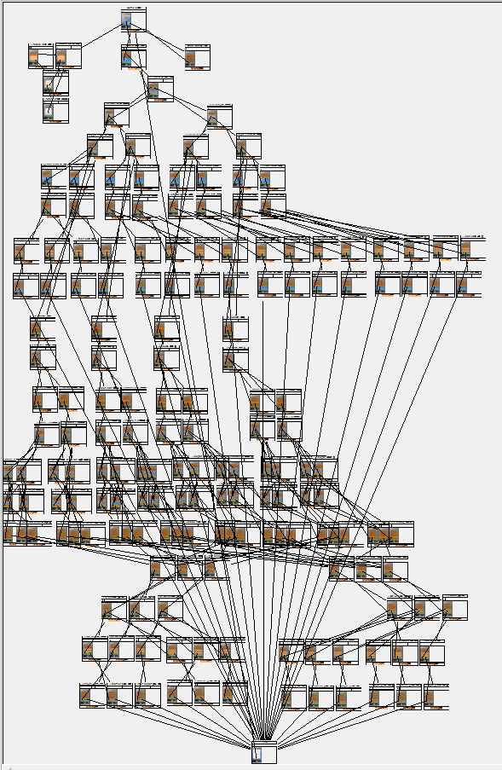

Zoomed (1 of 3):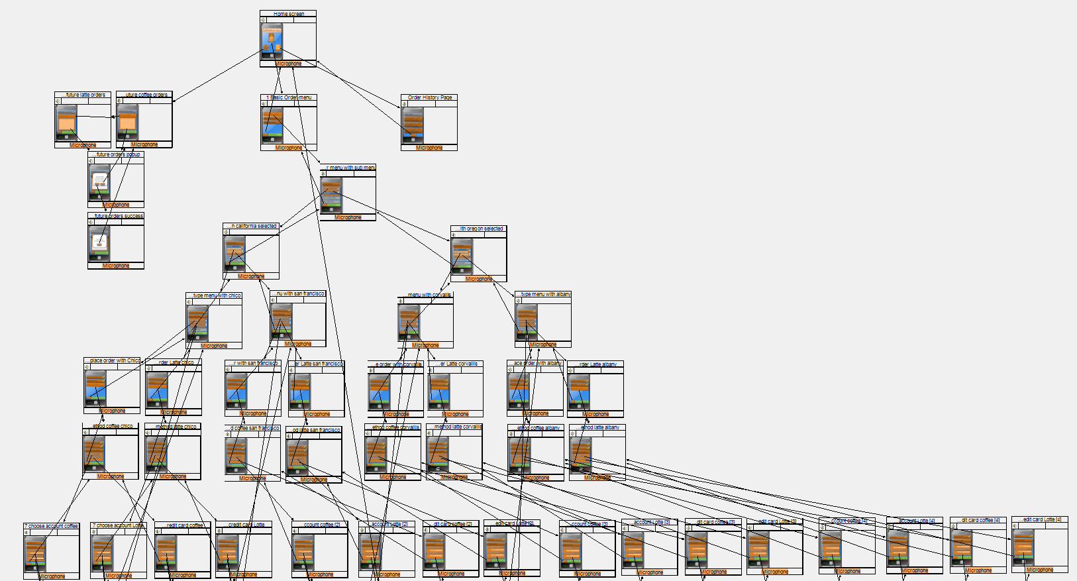

Zoomed (2 of 3): 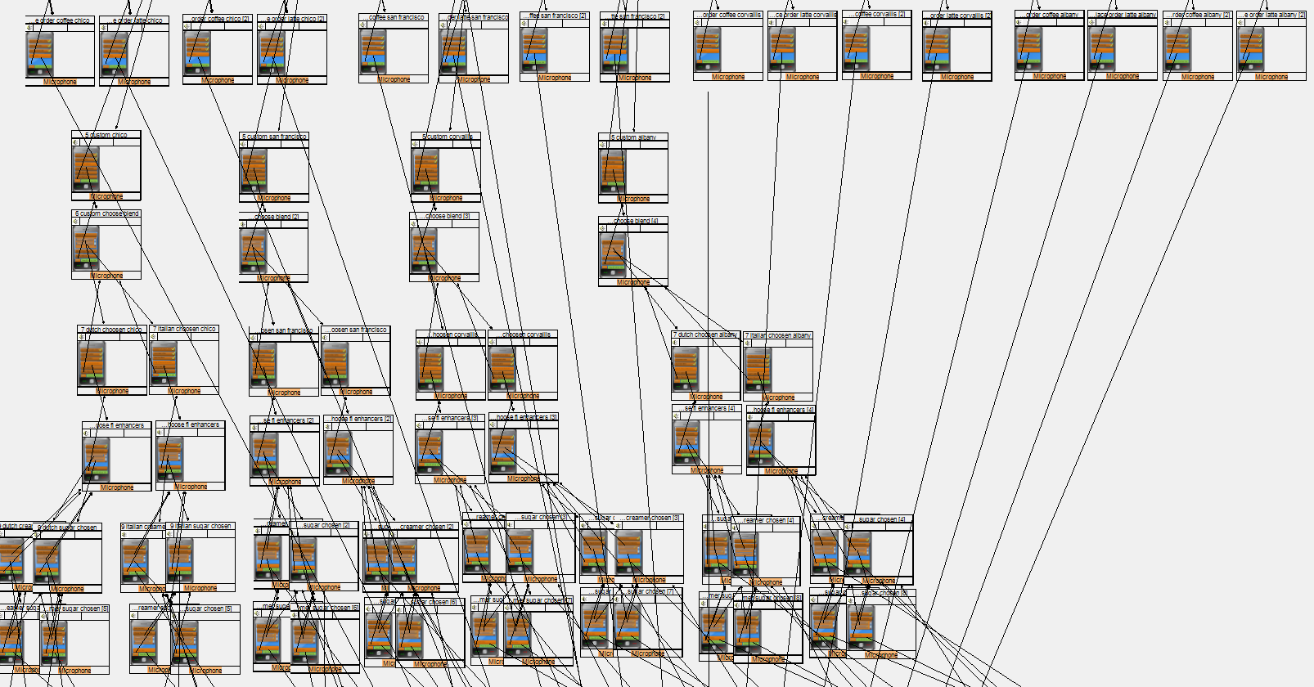

Zoomed (3 of 3): 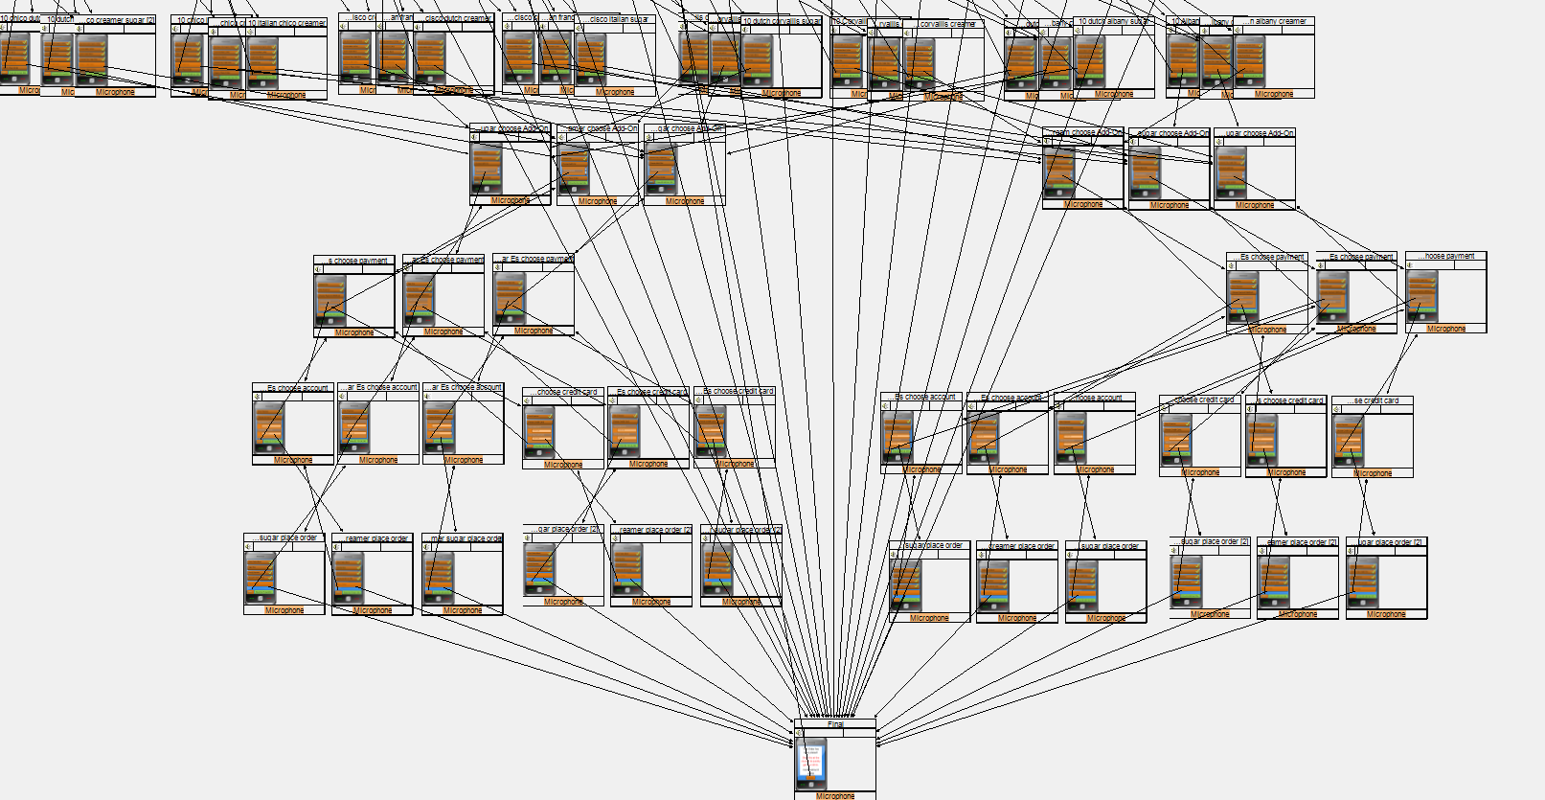

# The CoffeeNow App: User Research

## Research Questions/Goals

From our proposal we were able to derive a variety of research questions including:

* Is there a geographic difference in coffee consumption?
* Who is the most likely to use an app to order coffee? Who is the least likely to use it?
* What are customer’s biggest complaints when buying coffee/tea/whatever from a coffee shop?
* What’s the average wait time for customers using the current system?
* How would people feel paying for coffee with their phones?
* How does the name “CoffeeNow” sit with customers? Do they like it? Does it get across the purpose of the app?

Our goal for the research phase of this project was to answer these questions.

## Process

In order to answer these questions quickly, completely and accurately we modeled our interview questions in a structured format. That way each of the questions was covered no matter the interviewer/interviewee combination. In all, our team conducted thirteen different interviews with six male and seven female respondents. For further consideration we also conducted three free-flow observations, to balance against the structure of the interview process.

The interviewees were roughly evenly divided by sex, allowing us to stay gender neutral. Furthermore, it made it possible to triangulate the commonalties between people of different genders in order to obtain a coherent consensus. Many of the interviews and observations were conducted during the week, although some occurring on the weekend.

Most interviews have taken place on the west coast due to resource and time constraints; however some interviewees were located on the east coast (via Skype).

### Compiled Interview Questions

* What are your biggest complaints when buying coffee (is it standing in line, the price, etc.)?
* About how many times a week do you typically buy coffee?
* How much time do you typically wait in line?
* And how long do you wait for it to be actually made?
* How often after ordering your drink do you actually spend in the café?
* How often do you order other things (sandwiches, muffins, etc.) when ordering your drink?
* Do you feel comfortable taking your time when ordering at the counter or do you feel rushed?
* (If rushed) Why?
* If there was an app that allowed you to build our own cup of coffee and place your order before arriving, would you use it?
* How do you feel about paying for coffee with your phone?
* Is the name CoffeeNow stupid? Can you do better?

### Inventory

Our inventory for the Research phase of our project included both Field Interviews and Field Observations. During the field interviews, we focused on people and how they felt about a coffee shop’s services (i.e. what they liked and what they didn’t) and asked of potential ways it might be improved.

We asked whether they thought that their overall experience might be improved if the CoffeeNow app were available for them to use.

For the observations we primarily focused what individuals were doing (i.e. how they were interacting with the various objects within their environment). Additionally, we looked at whether what they were doing was related to their current task in a given situation. Finally, we attempted to discern how individuals felt about what was transpiring around them and describe their various reactions to any stimuli within their environment.

## Documentation/Evidence (Detailed Observations and Interviews)

### Field Interviews

What are your biggest complaints when buying coffee (is it standing in line, the price, etc.)?

1. Waiting definitely, also I’d like it if the prices were more reasonable, especially on campus.
2. Biggest concerns for me when I get coffee is the price and quality of the coffee. I definitely want the best quality at the lowest price. I like Starbucks, but I can’t afford to be there everyday. I will buy cheaper coffee like when I buy gas, I go into Chevron to get a cup, or go to 7-11 in the morning, but they just help me get through the morning and not as good as Starbucks. And if I go grab some quick breakfast at a fast food place, I will get a cup of coffee.
3. The price as it is getting more and more expensive. The one I usually get is more than $3 a cup (e.g., vanilla latte or mocha).
4. Usually just the lines. Sometimes I don't have enough time to wait before an appt.
5. biggest complaint would have to be the high prices followed by standing in line
6. Usually the price. I'm fairly cheap, or at least I think I am. You know that. :) Other than that, I like buying coffee.
7. The price, definitely. Coffee shop coffee is over-priced and often overly sweet. Waiting in line is a bummer also but I guess ranks second to price.
8. For me personally, I’m one of those people that gets forgotten, I pay for it, I order it and then it never happens.
9. Getting stuck behind people ordering fancy drinks, so for them to order quickly for my consideration.
10. There isn’t enough information about what each of the drinks are.
11. Mostly, standing in line. There are a lot of coffee drinkers at the time I go, usually 8 to 10 people when I get in line. I know when I go to my coffee shop I’m going to be in a long line.
12. Having to get out of the car, and the prices.
13. Waiting for my coffee after I’ve ordered it

About how many times a week do you typically buy coffee?

1. It depends on how I’m feeling; I’m actually trying to cut back. On average it’s about 2 -3 times a week.
2. I would say I buy coffee 4-5 times a week, maybe 1 or 2 times from Starbucks.
3. I usually make my own coffee. I only buy coffee one or two times a week. Or I will buy if I don't have a coffee with me on weekend.
4. Typically 3-5 times a week.
5. I buy coffee/tea maybe once a week. I brew my own at home for the most part. But occasionally treat myself
6. Usually 2-4 times.
7. Probably about once per week max, maybe once every two weeks.
8. 5 or 6 times.
9. 3 or 4 times a week.
10. Probably once every other week, we have an instant coffee maker at work.
11. I usually go in 2 to 3 times a week.
12. Um depends on the week, sometimes 1, sometimes every day
13. 0-1

How much time do you typically wait in line?

1. Usually about three minutes.
2. Waiting in line is not a big deal for me, its waiting for them to make the coffee that could take a while. I would say I wait for no more than 3 mins in line to pay when I go to Starbucks, but I may wait another 4 or 5 mins for them to make the coffee and get it in my hands. It’s about the same when I go to a fast food joint to grab breakfast and coffee. When I go to the gas station or 7-11, it takes me a couple mins for me to get my coffee because it’s self serve and maybe another 1 or 2 mins to pay if there is a line.
3. 5 minutes.
4. This varies as well. Sometimes less than 2-3 min. Other times it can be closer to 15 min
5. I am usually in line about 5 mins or so.. unless I am in disneyland and waiting at starbucks turns into 20 mins.
6. About 1-2 minutes.
7. Usually 5 minutes or less.
8. No more than 5 minutes.
9. Maybe 3 minutes, but it feels like it could be less.
10. They are usually pretty quick, except for the one by my office, and I won’t wait for more than 5 minutes.
11. I’ll probably be in line for about 20 to 25 minutes.
12. 1 to 5 minutes of hell
13. Generally in line for at least 5-10 minutes

And how long do you wait for it to be actually made?

1. About two minutes.

How often after ordering your drink do you actually spend in the café?

1. It depends, most of the time I’ll grab a seat right here in the Atrium, unless I have class.
2. I never stay around the café or restaurant because I’m usually heading to work. I drink it in the car and when I get to work.
3. I rarely spend time in a cafe.
4. Typically I do the drive-thru unless I am meeting someone there specifically.
5. usually after getting the coffee i ordered I usually leave the cafe right after
6. Usually about 1 hour. On occasion, I'll stay 30 mins or leave right after.
7. If I am meeting a friend to chat, I will stay for hours. If I am going there to work, I will stay for hours. Other than that, it's in and out. So, either several hours, or zero minutes.
8. Usually like an hour to two hours, typing or doing homework/drawing.
9. Usually not any time.
10. Sometimes I’ll spend 20 minutes or so in the shop.
11. I’ll stick around to read the paper, spending 25 to 30 minutes in the café.
12. I don't go to Cafes, remember, I don't like getting out of the car... and if I do I don't hang around unless I am there to visit a friend
13. 0 minutes

How often do you order other things (sandwiches, muffins, etc.) when ordering your drink?

1. Not very often, the coffee is expensive enough.
2. At Starbucks, I only order a drink. Most of the time when I am at the gas station or 7-11, I will get the coffee only unless I see a donut or something that catches my eye, which would happen maybe once every other week or so. If I’m at a fast food restaurant, I’m usually there because I want some food as well, like a breakfast sandwich.
3. I don't order other things besides coffee
4. Maybe 25% of the time, if that.
5. About every 3rd or 4th order.
6. Maybe 25% of the time.
7. I’d say half of the time, so 3 times a week.
8. Less than once a week.
9. Usually not.
10. Most of the time no, there are the few occasions when I buy a pastry or something.
11. Um pretty much never
12. Almost never.

Do you feel comfortable taking your time when ordering at the counter or do you feel rushed?

1. Most of the time I feel comfortable, I usually figure out what I want while I’m in line.
2. I usually know what I want already. If I don’t, I won’t line up yet until I see the menu, unless there’s a long line. I try not to change my mind by the time I get to the counter because I hate to hold up the line. I don’t feel rushed because of the employees at the store, but I don’t want to hold up the line because there are people behind me that might need to get to work on time too.
3. Sometimes I feel rushed. If I'm rushed and the line is long, I will just leave.
4. I usually don't feel as rushed at the drive-thru. I feel more rushed inside at the counter.
5. Always rushed. Always fumbling for my virtual money. Except at Dutch Brother's when I'm in my car, then I don't feel rushed unless people are behind me.
6. If there are people in line behind me or if I am in a hurry, then I feel rushed.
7. I don’t feel rushed, the place I go to has very laid-back people.
8. I do not feel rushed, possibly since I just order a black coffee.
9. I usually feel rushed at the counter, I just don’t know enough about the choices.
10. I feel a bit rushed because I don’t have the lingo down yet, like “half-caff”. Just because of that I haven’t branched outside of my regular drink.
11. I feel rushed, and like I am saying it all wrong! Haha
12. I feel rushed. Unless I’m ordering a plain cup of coffee…(am I weird that I do that?)

(If rushed) Why?

1. The line is long.
2. If there is a long line, people (both customers and workers) are anxious for you to get going and make it quick. You don't notice this as much in the drive thru.
3. I feel rushed if there is a long line behind me, I'm afraid they are getting irritated at me. If I'm already running late, then I am worried about being later.
4. Because I never know exactly what I want, or how to order it and get what I really want.
5. Wtf is a caramel mustard echo machicatto? Do I want the special? The people behind the counter talk too fast.

If there was an app that allowed you to build our own cup of coffee and place your order before arriving, would you use it?

1. If the app was offered free by the coffee house, then I could see myself using it.
2. Sometimes, if I know I will go to that specific store and know what I want because the morning routine might change from day to day. And it might be hard to use the app on the phone while I’m driving. Besides, I don’t think we are suppose to use our phone while driving.
3. It's a good idea. I'll definitely try if there's an app for ordering coffee ahead of time. So save time and no need to wait in line.
4. Absolutely.
5. When I am in disneyland and waiting at starbucks turns into 20 mins. was just there in December and man I wish I had this app you are making lol
6. I would try if it was free. It would seem a bit odd to show up and not have to order, so I'd have to get used to NOT ordering and figuring out where to go when I get there and whether my drink will still be hot. The timing would be a challenge too. What if I'm late, what happens? FAQ's would be in order, for sure.
7. Yes, I would.
8. Yeah, probably.
9. Yeah I could see that, it depends on the coffee shops that don’t have lines. But at another place with a long line I could see using that app.
10. Yeah I think so, I have the Starbucks app, but I don’t tend to use it. When I go to a coffee shop, its spur of the moment, if I went regularly, I might use the app to save on time in the line.
11. Yes, I would definitely use that.
12. YES!
13. Maybe. If it were free

* How do you feel about paying for coffee with your phone?

1. Wouldn't bother me.
2. not a problem
3. Fine with it. I use my Starbucks app all the time. Of course, only if it's the same price I'd pay in the store.
4. I am slightly suspicious of new technologies. If it's like the thing where you wave your phone in front of a reader and it deducts it form your account, then I am suspicious. If it is just using the internet with your phone and paying via PayPal or something, I am less suspicious.
5. I actually don’t mind, if I trusted the software. Not opposed to technology.
6. I would want to be familiar with the network that was providing that service, (paypal). If it was a random app, then I probably would not use that service.
7. I would totally do that.
8. I do that now using the PassBook application on my iPhone.
9. I use my starbucks card on my phone all the time!
10. I haven’t paid for anything with my phone yet. I would do it if I had the technology (data plan).

* Is the name CoffeeNow stupid? Can you do better?

1. It isn't stupid. Maybe myCoffee?
2. meh
3. I wouldn't say it's stupid. Definitely clever. I can't do better right now though, but if you have other ideas, I'd be glad to hear 'em. :)
4. I like it.
5. No, it’s a pretty good title, its simple. It is what it is, you don’t want to be too fancy. Definitely want that word “coffee” in there.
6. I feel like that’s a solidly middle of the road name, don’t have feelings for or against it. Less literal perhaps.
7. I feel like we all know what Coffee is, it’s that thing you drink that’s nutty, brown, etc. But you never see a coffee shop that’s called “The Coffee Shop”, they try to dress it up using things like “Java” or “Bean”. “Coffee” may be too generic, like a commodity.
8. I think it’s appropriate from the basis of the questions, getting your coffee without the intimidation factor of having to know what you want to order.
9. The name works, or at least I can't come up with anything better...
10. That depends on your opinion of stupid…no, but here’s what I thought of in a couple of minutes…I don’t think they are any better than CoffeeNow. Instant Joe, Joe, Java Lava, GMMFCN. (give me my freaking coffee now). Mycup. Ejava, Ejoenow, Happy Happy JO JO, Easycupojoe, Lovecoffee

### Observations:

#### 1/25/2013 @ Starbucks, Newport Coast CA

* Man with glasses, mid 50s wearing a leather jacket waited in line for 3 minutes, when paying an espresso pulled out his smart phone to check something, paid with a credit card. Walked over

to receiving area, then walked to the restroom while his drink was being made. When he comes

out, gathers his drink, checks out the paper on his way to the fixings table. Pours in sugar,

comes back to the barista and asks for his breakfast sandwich near the back of the line. Takes

both and sits down to eat and drink @10:20. Plugs in headphones to his smart phone while

eating. @10:36 man zips up his coat and walks out, leaving behind his plate and empty shot

glass.

* 10:24 Young girl, mid 20s wearing a knitted hat and boots, looks at her iPhone while waiting in

line, 30 seconds. Orders a pastry and drink, pays for it using a credit card. With no wait for her

drink, she receives it after 3 minutes while nibbling on the pastry. Takes drink and leaves.

* At 10:25, there are 7 smartphones in the café, with 8 people here. However, no customers have

paid using their smartphones.

* 10:30 Older woman, mid 40s/early 50s having a ponytail and wearing a sweater orders a large

iced drink and breakfast sandwich. Pays using cash, no indication of having a smartphone. Waits

for her drink for 2 minutes by the fixing table. Grabs a straw and leaves.

* 10:32, 40 year old guy wearing a wool hat and plaid shirt walks in with his hands in his pockets orders his drink paying with credit card. Walks to the newspaper stand and picks one up reading for 30 seconds, then puts the paper back. Waits two minutes for an in iced drink, grabs a straw

and leaves.

* 10:34, 55 year old man wearing a button down shirt orders a drink, grabs a banana, and pays for

it with cash. Talks to the barista for a few minutes before handing her a business card. He

seems to have a rapport with the barista. Waits for his drink and leaves.

* 10:38, 60 year old woman wearing earphones listening to her iPhone comes in with a younger

girl (granddaughter?) asks a question about a drink to the cashier. Girl wearing sparkly pants

looks at a Bruno Mars CD. Woman pays for a drink for herself and for young girl with her credit

card after a couple minutes. Talks to barista while making drink.

* 10:42 two men wearing dress shirts come in using smartphones. One pays for his drink using

cash, then stands by the newspaper stand shuffling back and forth waiting. After two minutes

of waiting, he grabs his drink then beelines for the door. Seemed to be in a rush, most likely

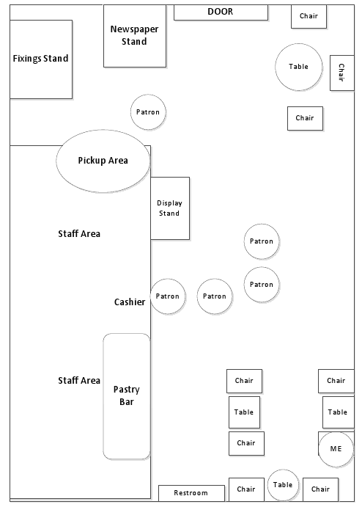heading back to work. The other pays for his drink using his smartphone(!!) before walking over

to the bathroom, tie in hand. Uses the bathroom for 2 minutes, comes back out wearing his tie.

Heads directly over to receiving area then out the door. Likely going to work for the first time today.

* 10:47 Man late-50s walks in wearing glasses and a dress shirt, waits 3rd in line while rubbing his

glasses with a cloth. Looks at the ordering board then around. Has a smart phone hanging from

his belt. Checks out the various pastries and sandwiches, now second in line. @10:49, quickly orders drink and pays for it with a credit card. As his heads over to the receiving area, he puts the card back into his wallet and pulls out his smartphone. Attention is now entirely on smartphone until his drink arrives. Gets drink and goes back to looking at smartphone. Must be waiting for a sandwich. Correction, had to finish something on his phone, then grabs a sleeve for his drink and walks outside. Stands outside for a minute sipping his drink before moving on.

* Spoke with cashier before leaving at 10:55, she says that about half the people who come in to order something are using their smartphones to pay for it. Early mornings perhaps?

#### 1/24/2013 @ Kelley Atrium “e-café”, Corvallis OR

The person who I decided to observe was a 20 year old female wearing rolled up jeans, a black rain coat, a backpack, and what looked like slippers. At 9:56am she walked up to the line in the coffee center. She was the 9th person in line (This is usually the busiest time). While she was standing in line she had both her hands in her rain coat pockets. While she was waiting she looked around and continuously shifted her weight from foot to foot (I think due to impatience) as if she had somewhere she needed to be. She pulled out her iPhone with a bright orange case for what I can only assume was to check the time. She then pressed a few buttons and it looked like she was reading something on her phone. It looked like emails or possibly texts. She then put her phone back into her front rain coat pocket, checked her hair and tugged on her pony tail. She put her hands back into her front rain coat pockets as she continued to move slowly forward. Next to her there was a stand with some fliers of upcoming events at OSU. She casually browsed them. As soon as she was next in line to place her order she began to look intently at the items within the glass case next to the counter.

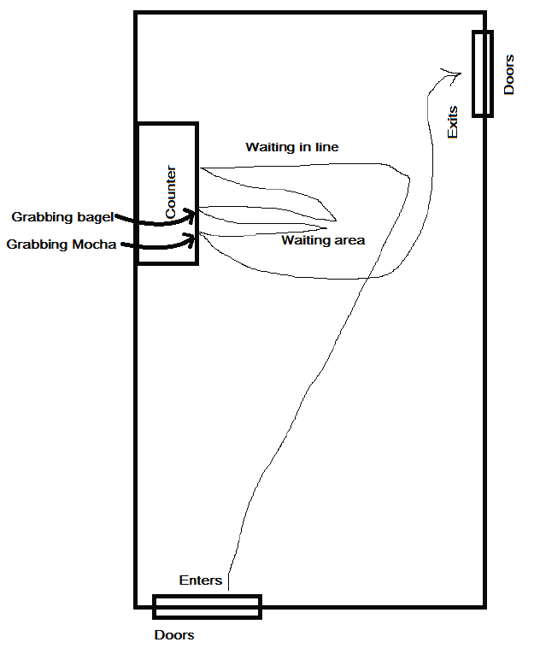When it was her turn to place her order, she ordered a medium white mocha and a bagel with cream cheese. She then pulled out a lime green change wallet and grabbed out her credit card to pay for the purchase. As soon as her credit card had been handed back to her, she put it back into the wallet and took the backpack off, placing the wallet back into it while walking to the waiting area to wait for her order. So at about 10:00am she pulled her out iPhone again and started texting (because her thumbs were moving really fast!). She looked like she was concentrating really hard on what she was writing when one of the people behind the counter called out, “Bagel with cream cheese!” When she heard that her head popped up and she grabbed the bagel and cream cheese on the counter. She then walked back to the waiting area. She stuck the bagel between her arm and her body and continued to read and text until she heard, “Medium white mocha!” Her head once again came up and she looked around like she wasn’t sure if it was for someone else. When she realized it was her drink she went up to the counter, put her iPhone back into the rain coat pocket and grabbed the mocha. The time was 10:05am when she grabbed it. She then proceeded to walk out of the coffee center at a semi-rapid pace. Thus, the total time for her order had been approximately 9 minutes 20 seconds. With approximately 4 minutes of waiting in line. With an additional 30 seconds to place her order and pay. As well as waiting 4 minutes and 30 seconds for her order to be completed.

#### 1/29/2013 @ Coffee Bean, Irvine CA

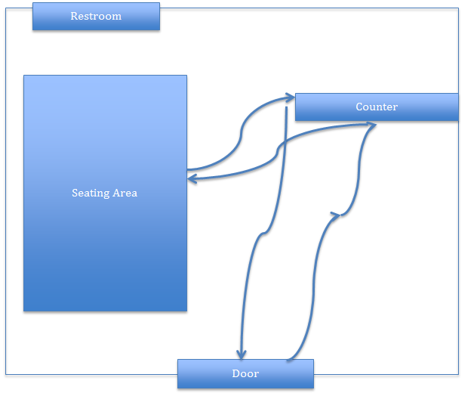The coffee shop that I went to is inside a large shopping plaza. It was a weekday afternoon. There weren’t many customers in the shop (there was a total of four customers, including myself). At 3:40PM, a woman who looks in her 50s came in. She was wearing a red sweater, black jeans, and a purse. There was a young man behind her. He looks in his early 20s. He was wearing a hoodie, blue jeans, and tennis shoes. They look like mother and son. I decided to observe them and their behavior.

Below is what I noted:

* There was no wait line.
* They smiled at the cashier before looking at the menu.
* The woman turned to the young man, asked him a question, then pointed to the menu.
* They started talking while still looking at the menu (I believe they were discussing their order).
* (About 1 minute later) They walked up to the cashier. The guy told the cashier what they wanted. The woman took out her wallet from her purse and paid by credit card.
* They walked away from the cashier and sat down in the seating area.
* While they were waiting for their order, the woman opened her purse and took out her phone. It is not a smart phone. She opened it, stared at the screen for a couple seconds, then closed it and put it back in her purse (Assumption: She probably wanted to check if she has any miss calls or new voice mail).
* The guy took out his iPhone from his pocket. He started playing with his phone.
* (3-4 minutes later) The cashier calls ,“Jeff.” Both the woman and man went up to her and picked up their order. They ordered 4 coffee drinks.
* They left the shop at about 3:55PM.

## Insights, or Our Key Findings:

* - Price is the biggest concern, followed by wait time.
* - On average, customers wait about 3-5 minutes in line.
* **Insight:** Our app can help coffee shops improve their customer experience by reducing wait time.
* - Few customers order other items (e.g., sandwich, muffins) besides coffee.
* **Insight:**  This finding gives us an idea of what we can focus on in our app design (e.g., coffee menu or anything that is related to coffee drinks). It also suggests that non-coffee items are less likely to be viewed by customers and can be minimized or hidden from the screen.
* - Regardless of geography, customers bought their coffee in largely the same manner
* **Insight:** Our app can have a broad range of appeal by addressing the basic concerns already discussed, doesn’t need specific geographic targeting.
* - All of our interviewees are interested in getting an app that allows them to order coffee from their phone, especially if the app is free.
* **Insight:** Coffee lovers are likely to try a coffee app, but the cost of the app needs to be affordable. If possible, we should allow customers to download and use it for free.
* - Most of our interviewees think it is fine to pay for coffee with their phone.
* **Insight:** We need to make sure our app has no data security issues.
* - Some interviewees liked the name “CoffeeNow”.
* - Others were ambivalent or could not think of anything better.
* - Still others did not like the name, or thought it lacked pizzazz.
* - This question sparked more diversity of opinion than any other. For instance, one respondent said that the word “coffee” should definitely be in the name while another respondent said the word definitely should NOT be in the name.
* **Insight:** App naming is pretty subjective, we can probably keep our app name as it is, but it wouldn’t hurt to explore alternatives.

# The CoffeeNow App: Evaluation

## Analytical Evaluation:

The goal of this analytical evaluation is to better understand the efficiency of the interface as it is currently constructed. The main task we wanted to cover with our prototype CoffeeNow application evaluation was whether our interface provided an efficient method for both customizing and ordering a cup of coffee from the user’s favorite coffee shop.

In order to obtain a clear metric by which to judge how a skilled user would use our application to place an order for a personalized cup of coffee we used GOMS/KLM. This analysis method provided us with an accurate metric to measure how efficiently a skilled user orders a cup of coffee with the app. This is accomplished by measuring both the time and effort that must be exerted by the user to achieve their goal.

For this analysis we made the assumption, based on our interviews and observations, that our target demographic included both males and females which own a smart phone and drink coffee regularly. Obviously from this description our application will potentially have a large target demographic. So to keep much of the complexity involved with individual differences we decided that measuring the time it takes users to order a Dutch flavored coffee, with a shot of espresso, with cream and sugar, would be a valid use case.

In particular, we wanted to get an accurate time measurement for placing an order to better understand and compare this value with that of the average time our users would spend ordering a cup of coffee in the regular way. Viewing the difference in time would allow us to better understand whether we were in fact solving the problems presented in our project proposal. Namely, the large amounts of time wasted waiting in line to order.

Further, we analyzed how easy the overall process was for a skilled user. The main criterion that we used for this evaluation was both the time it took and the number of steps (i.e. button presses) that were needed to complete the task of ordering a cup of coffee.

The tool that we used to perform the analytical study was CogTool. We used the built in GOMS/KLM measurement to better understand the time and the total number of steps that were involved for a skilled user to order a cup of coffee. Using CogTool and our prototypes we created a script that measured both the total time and the total number steps (and button presses) involved for the user.

So from having our skilled user (one of our team members) using our prototype interface in CogTool we collected the following data:

Using the GOMS/KLM procedure with an average think time of 1.2 seconds for a skilled user we found that a total of 14 button presses were needed to select the pick-up location, select regular coffee with a Dutch blend, along with regular cream and sugar, and a shot of espresso and finally place the order. The figure below shows all the intermediate steps executed in the script.

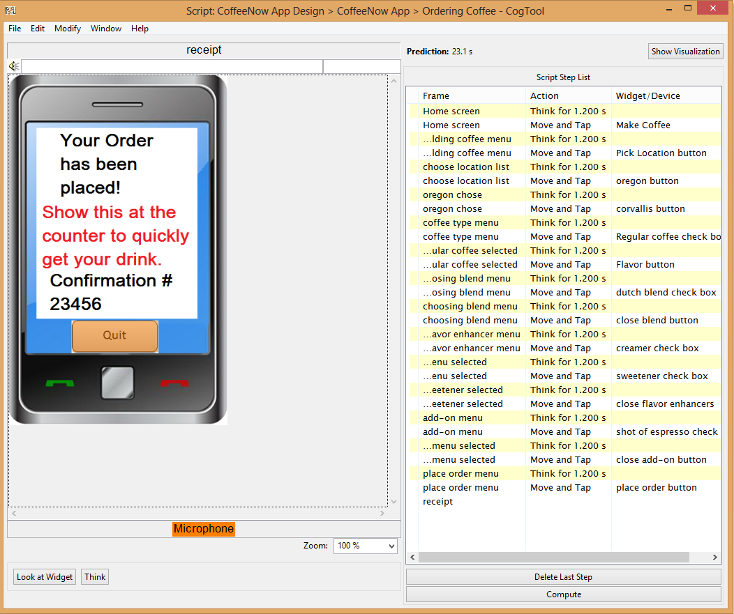

To place this order we found that on average it would take a skilled user approximately 23.1 seconds in total. Looking back to the data from our interview and observations, we can see that it indicated that the average wait time for users to wait in line to place their order was around 3 minutes with an additional 2 minutes waiting for the order to actually be fulfilled. With our application we found that we would be saving users an average of,

5 minutes – 23.1 seconds = 4 minutes and 36.9 seconds

Furthermore, assuming that our users order coffee at least 3 times a week, as indicated by our observations and interviews, we would be saving our users a total of 13 minutes 50.7 seconds on a weekly basis. This analysis of course does not include the additional benefits received if a user orders more than one cup of coffee in a typical day.

Overall, our application provides our users substantial time savings especially when extrapolated throughout a typical user’s lifetime. Likewise, the number of steps at, 14, while longer than we would have liked, was provided to the user in a wizard-like format helping the user to recognize and get used to the screens and the order in which they occur to help them navigate the interface more quickly. Hence, from our time and number of steps evaluation we feel that analytically speaking our project solves the problems our users were having with wait times at coffee shops.

## Empirical Evaluation:

* Research Goal
* The goal of our usability study was to test the prototype of the CoffeeNow app with users.
* Method

We used the “think-aloud” technique to evaluate whether our application works by answering the following research questions:

* Did users place their order successfully in the CoffeeNow app?
* Did users stop at any steps and ask questions? If yes, what did they ask?
* Did users make any comments on the features/labels while they were using the application? If yes, what are their comments?
* Do users think the app save their time?
* Do they see themselves using this application if it is available? Why/Why not?

The “thank-aloud” technique was chosen because we wanted to observe how users use our prototype and gain a better understanding of their thinking process.

* Participant

We randomly selected one male and one female from our previous research/interview assignment. Both participants are in their late 20s/early30s, drink coffee regularly, and own a smart phone.

* Prototype Tool
* CogTool demo
* Procedure

Each participant was interviewed by one of our team members. Both participants used the CoffeeNow application to order a Dutch flavored coffee, with a shot of espresso and with cream and sugar. They talked constantly as they did the task. After they completed the assignment, they answered three follow-up questions. Our team members recorded all the questions and comments the participants had about the application. Both interviews lasted about 10 minutes.

* Data
* See the CoffeeNow Evaluation Appendix for our interview data.
* Result
* All of our research questions are addressed in our protocol analysis.
* Both users placed their order successfully in the CoffeeNow app.
* Users found the task confusing when proceeding from step 3 to step 4.
* One of the labels (i.e., “anything”) in step 4/Flavor Enhancer is unclear to users.
* Users think our application is missing some important features and suggest to add the following:

1. An option to choose the size for their drink
2. An option to choose the amount of flavor enhancer
3. An option to order non-coffee items (e.g., food/tea/water)
4. An option to go back to the previous steps
5. An option to choose the pick-up time
6. Add more choices (e.g., honey or agave) to Flavor/Enhancer (step 4)
7. Add a page dedicated to the options available in the add-ons
8. An option to add comments
9. Display a message to inform customers how they can retrieve their confirmation number
10. Let customers know how they can pay for their order

* One user thinks the app would save her time, whereas the other thinks it might if there is a special line for online ordering.
* One user said she would use our application if it is refined. The other indicated he would use it if he can save time and the coffee is fresh at pick-up.
* Insight for our prototype
* We can enhance our prototype by including the options our participants recommended (e.g., option for customers to choose the size of their drink, the amount of flavor enhancer, pick-up time; and allow them to go back to the previous steps to edit their order)
* We need to add an icon (e.g., “next” or “ok”) to the bottom of each screen, rather than having users to tap the top bar to enter their selection.
* We need to change the unclear label and add more choices in step 4/Flavor Enhancer.
* We can provide an open-box for users to add their comments.
* We need to improve the visibility of the confirmation number location so users know how to retrieve it.

# Appendix A

## Evaluation Empirical Data – Think-Aloud Interview #1

Date: 02/18/2013

Participant: female, late 20s/early 30s regular coffee drinker and smart phone user.

Notes:

Interview took just under 10 minutes to complete. The subject first went to pick-up location, and selected Corvallis, OR as her “location”. When she went to select her coffee, she picked “regular coffee”, but then asked where Dutch flavored would be. It did not seem to be clear to her where to click next to get the type of coffee she was ordering. After selecting Dutch, she said “there is nothing else to prompt you…there’s no place to hit submit”, which suggests that we need to make this step in the process a little more user friendly, maybe by having the next step button directly below the blend of coffee. She then hit the only option she had, which was “choose coffee” and it took her to “flavor enhancers”.

After selecting her enhancers, she commented that she likes to have honey or agave, and that “sweetener” isn’t specific enough. She thinks that people are very specific about their coffee and they will want to know exactly what is going into their drink. Also asked about “anything”, “spice” (nutmeg, cinnamon, ?) and said there needs to be more options. She said she wouldn’t even want to use the app as it is now, because she needs more options. Sounding frustrated, she said “using what I learned from before, I’ll select flavor enhancers again”. She asked about adding comments, probably because she was frustrated about the app. She asked about being able to pay for it now.

Wrapping up the interview, we had some follow up questions. She though the app would help her save some time ordering her coffee. When asked about concerns about the app, she explained how the app went directly from selecting location to selecting type of coffee with no clicks in between, but then it became more confusing to use as she had to click a button to get to the screen with the type of coffee, then very confusing as she had to click on buttons like flavor enhancers again (which were located in illogical locations). She said she wouldn’t know what to do at those points. She would rather have the flavor enhancers come up immediately without having to click on other buttons (like when the app went from location to beverage). She said it was not very intuitive. She said she would use it if it were refined and you could order food/tea/water etc. When asked if there were any other ways we could improve the app, she said that we should have a full page dedicated to the options available in the add-ons. Don’t show the checked boxes, but provide those extra options that people would want.

She asked where we would get out drink from, and also how the coffee would get paid. She wanted to see something that said what card or method of payment was used to pay for the drink in the confirmation.

## Empirical Data – Think-Aloud Interview #2

Date: 02/20/2013

Participant: 33-year-old male who owns a smart phone and drinks coffee everyday

Notes:

*Do users place their order successfully in the CoffeeNow app?*

Yes, the participant placed his order successfully in the app.

*Did users stop at any steps and ask questions? If yes, what did they ask?*

Yes, he stopped a few times and asked questions.

* Step 1/Location: He selected Los Angeles in California as the pick-up location. When the next screen shows Corvallis in Oregon as the pick-up location, he asked why the location is wrong.
* Step 3/Flavor/Blend: After choosing blend, he asked how to go to the next step.
* Step 4/Flavor Enhancers: For the flavor enhancers, he asked what does “anything” mean?
* Step 4/Flavor Enhancers: He asked how could he tell them how much cream or sweetener he wants?

*Did users make any comments on the features/labels while they were using the application? If yes, what are their comments?*

* He could not go back to the previous steps to change his order.
* After placing the order, he realized it did not ask him for a size for his drink.
* He was confused when he got to the last screen display (i.e., Confirmation number/Quit). He was unclear whether he could leave the screen and quit the application or if he had to leave that screen on until he gets to the coffee shop. He’s not sure if his confirmation number was saved and will show up again if he opens the app.

*Follow-up Questions:*

*Do users think the app save their time?*

“Maybe. It depends on the line when I get there. I still have to get in line and show them my confirmation number. Will my coffee be sitting there getting cold? Or do they make it when I get there. I don’t think it’ll save me that much time if I have to wait unless they have a special line for people that place the order using the app.”

*Do they see themselves using this application if it is available? Why/Why not?*

“Maybe. Depending on how much time it saves and if my coffee is fresh and not made a long time before I get there.”

*Is there anything else you would like to share with me on this application?*

1. “It’s hard to add the selection to blend and flavor enhancers because there is no icon at the bottom to select ‘next’ or ‘ok’. It took me a little bit to find out that I have to tap the top bar to enter my selection, which is confusing. “
2. “Make the confirmation number bigger so the employee can see it more clearly so they won’t give customers the wrong drink.”
3. “Add a feature to allow customers to choose a pick-up time so their order won’t be cold.”

# Appendix B

## Interactive Design Feedback

### Nick Alto

Your app does a very good job showing the steps required to complete the task of ordering coffee, this allows users to easily calculate the cost and payoff of completing these steps. Each step has a very strong scent that allows for the users to easily know how to complete each step and proceed to the next screen. I also found that the element of surprise was very well captured in outlining each step from a high level leaving the user interested in finding out what information is required for that given step, it definitely peaked my curiosity. My only pieces of criticism stem from the inability to go to the home or main menu during these steps (which might just be a limitation of prototyping within CogTool), if a user wanted to go back to check their previous order history to make a variation on a previously purchased drink. Also I think the schedule functionality on the home screen would be better integrated into the make coffee/place order button, giving the user an option to specify if they want the coffee ready by a certain time to pick it up, or of if they just want to skip the line in the actual coffee shop. Other than that my only issues are the color schemes such as black text on a dark-colored button and the use of more complimenting colors (different hues of a similar color as opposed to pink, blue, brown, black and green in a single screen). Overall I think you have a very solid application with a very intuitive progression of actions, well done.

### Alex Carpenter

I really liked this app it felt very simple to use and very straight forward. After going through it the only complaint I had was where are the back buttons, I think it might be a good idea to add them so that people who makes mistakes mid way through ordering thier coffee can cancel the mistake and then continue with the order rather than having to start from the begging. Really other than that I think it looked great.

### Jimmy Brewer

This is a quick and clean app that does what it says and no more. What I can not tell from the prototype is if I can change options after confirming the step, or do I need to start over.

### Charles Clampitt

Very clean and simple. Usually these are good ideas when they are that clean. My feedback is that I did not see the navigation that would allow me to move back. I would assume I would use the back on my droid but I would only be guessing.

### Evan Chacker

I have to agree with most comments, it looks great. I especially like the addition of the pick-up time which makes it much more functional. I imagine in the real app I could just skip to the complete order (I drink my coffee black).

### Kevin Nider

Users should be able to return to a step they just completed in case an error was made. Once inside the step, the Step navigation shouldn't still look like a button, and should allow the user to go back. I'm also hoping that I don't have to add flavor enhancers in order to place my order.  
  
One element of surprise could be a deal that slides up once the location is selected and the user is on Step 2. It would have to be quite small, only hinting at what the deal is and saying the coffee places name. Once it is tapped, it should slide up to give the whole details of the deal. Or since the order review page has a calorie count, once you select a flavor enhancer it tells me +[number of calories].  
  
One last thing, on Step 2, the bottom button might be better as "Complete Step" instead of "Step Complete". That's an action instead of a state.

### Sam Best

I like the design, it seems really easy to use but still gets the job done. I think you could improve it by finding a way to reduce the perceived time cost of making an order by hiding the flavor enhancers and addons initially. To me it seems like a lot of steps for just ordering a coffee, especially if all you want is a standard latte or cup of coffee. I didn't think I should have to go through all of those steps if I didn't even want anything custom, and maybe I wouldn't have to, but having them all laid out like that makes it seem like I would.  
  
To improve this, you could change the interface so that the order page only has a simple thing at the top allowing users to set their pickup location, then instead of breaking everything into distinct steps, just show all the possible menu items underneath and save the customization until the user selects a menu item. Once they click latte or whatever drink, move to a new screen. On the new screen, allow them to choose a size, (12 oz, 16 oz, 20 oz, etc) and say what's in the drink (half and half, 2 shots espresso). If all they want is the standard drink, they just click a button to go to payment options. If they want to customize it, there would be options for adding flavors, cream, choosing the type of milk (skim, 2%, soy), and whatever else people might want. It's pretty much the same concept as what you already have, it just makes it seem like a shorter process to me if you don't show all the steps upfront.  
  
One other suggestion--I think you could improve on the reorder options by taking advantage of the surprise-explain-reward concept. One way would be to have an option after a user makes an order to quickly set up a schedule for that same order. Maybe the surprise would be a button that says "regular order? try using the scheduler," and when the user clicks it it automatically brings that order into the scheduler section, where it explains the feature and lets them set up a schedule.  
  
I have to say, when I first saw this idea I wasn't sure about it, but after seeing your prototype it seems really useful. I like the idea of being able to see all of the options for customizing my drink without having to ask and hold up the line. I would probably go to the coffee shop a lot more if this was a real app.

### Savannah Van Beek

This app would be awesome, especially for someone on the go and wanting to get in and out quickly without having to stand in long lines. The format you use is clear and easy to read and navigate, but there are a couple suggestions I have. One would be a place for the user to give a tip or if the user has a coupon. There’s no place for someone to put in a promotional code of sorts. Another thing I noticed was that there is no way to clear out the order history. Also, would that be where the user would show the confirmation number? How else would the user navigate back to the receipt? One last thing that I noticed was that users were forced into choosing a flavor enhancer before they could move on. I’m not sure if that is just a fluke with the prototype or if it was designed that way, but I do know a hand full of people who like plain coffee. These are all very small and easy fixes. The rest of the app looks great!

### Mario Moya

Apart from the help/error-prevention measures that have been suggested in previous posts (e.g., back button, home screen navigation, etc.), I do think this is a well-designed application. I anticipate that it would be a very popular application and worth the attention investment in learning how to use it. When I think about my busy mornings, one of my least favorite things to do is wait in line, especially at a noisy coffee shop. That said, my perceived payoff of using this application would be to avoid waiting in line on a daily basis (which are minutes that will add up over the course of a year), and the perceived costs of learning how to use the application are relatively small in comparison. (The revised design actually lowers the perceived costs of using the device by allowing users to review their recent order histories and make the same orders, etc.) Lastly, the risks that I would perceive as a user are relatively minimal: (i) there might be an error in my order and it might not go through (or, perhaps, double-charge me), and (ii) my coffee might be cold when I retrieve it (depending upon when I placed my order). These risks pale in comparison to the perceived benefits I previously mentioned. That said, good job on a well designed application.

### Seamus Mahoney

I found the app intuitive and functional. It was simple to get through and place an order. For feedback I would say that listing all of the steps at once isn't necessary. If they all need to be gone through and in order, why should the user have to click them in the fist place? They could be used as titles at the top of the screen with an arrow button taking the user to the next one, and show the screen to be 3/7, 4/7 etc.. This would make the interface simpler and rely on scent to guide the user instead of making everything explicit. Also I was surprised to see the calorie count when I finished placing my order. This was great information, but would have been more helpful if it was displayed as I was building my drink. It would fit the surprise explain reward dynamic well if you saw calorie count when you picked a drink, and saw it adjust as you customized it with sweetener or cream. You could also add info boxes for the various coffee blends, it's nice to see options but giving an explanation of those options would make it much easier for a user to make a choice.